Launching an EC2 Instance on AWS
Step-by-step guide for launching an Amazon EC2 instance on AWS.

Step 1: Log in to AWS Console
Open the AWS Management Console and log in with your credentials.

Step 2: Navigate to EC2 Service
Search for 'EC2' in the AWS services and select it to open the EC2 dashboard.

Step 3: Launch a New Instance
Click on the 'Launch Instance' button to begin the setup.

Step 4: Configure Instance Details
Enter an instance name, choose the Amazon Linux 2 AMI, and select the 't2.micro' instance type (Free Tier eligible).

Step 5: Create or Select a Key Pair
Create a new key pair or use an existing one. Download the .pem file securely.

Step 6: Configure Network and Security
Allow SSH access (port 22) in the security group settings.

Step 7: Review and Launch
Review all the settings and click on the 'Launch Instance' button.
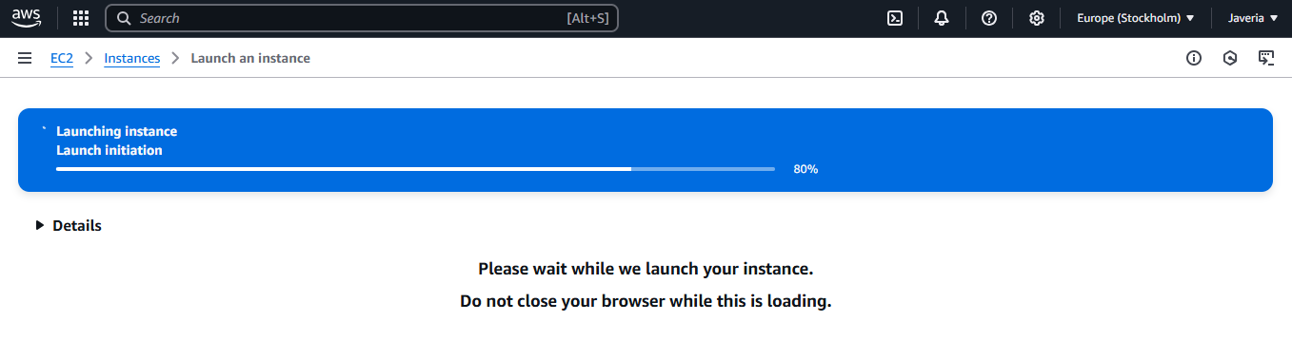

Step 8: View Running Instance
Navigate back to the EC2 dashboard to verify the instance is running.
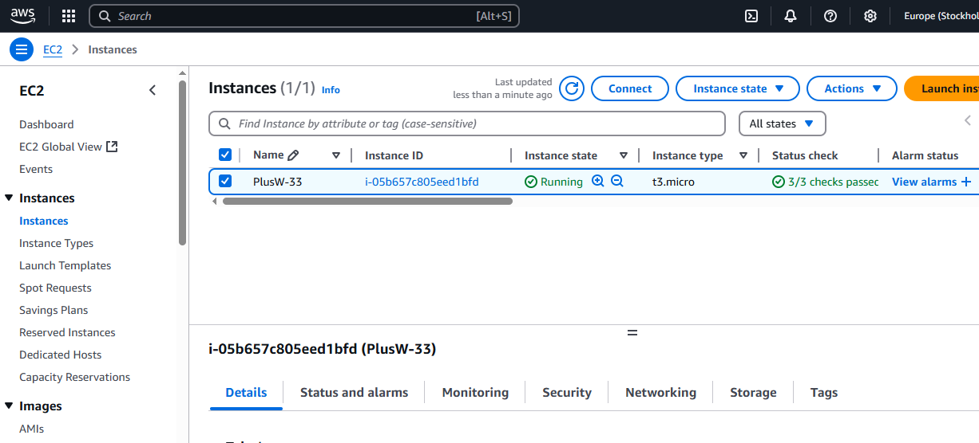

Step 9: Connect via SSH
Use the following command to connect to your instance:
ssh -i plusW.pem ec2-user@<my-public-ip>

